**MEERUT INSTITUTE OF ENGINEERING AND TECHNOLOGY**



Session: 2021-2022

**MINI PROJECT REPORT ON**

“COLLEGE WEBSITE”

**BACHELOR OF TECHNOLOGY IN COMPUTER SCIENCE AND ENGINEERING**

**Submitted to-**

**Ms. Shweta Saxena**

**(Department of Computer Science & Engineering)**

**Submitted by-**

# Student name - Ayush Kumar Chaudhary & Roll No: 2000680100089

**Arshit Tyagi 2000680100071**

**3RD SEMESTER DEPARTMENT OF**

# COMPUTER SCIENCE AND ENGINEERING MEERUT INSTITUTE OF ENGINEERING AND TECHNOLOGY,

**MEERUT**

# DECLARATION

We hereby declare that the project entitled - “College Website”, which is being submitted as Mini Project in department of Computer Science and engineering to Meerut Institute of Engineering and Technology, Meerut (U.P.) is an authentic record of our genuine work done under the guidance of Assistant Prof. “Ms. Shweta Saxena” of Computer Science and Engineering, Meerut Institute of Engineering and Technology, Meerut.

Date: Ayush Kumar Chaudhary &

Arshit Tyagi

Place: MEERUT 2000680100089,2000680100071

(i)

# CERTIFICATE

This is to certify that mini project report entitled – “College Website” submitted by “Ayush Kumar Chaudhary & Arshit Tyagi” has been carried out under the guidance of “Ms. Shweta Saxena” of Computer Science and Engineering, Meerut Institute of Engineering and Technology, Meerut. This project report is approved for Mini Project (KCN 354) in 3rd semester in “Web Development” from Meerut Institute of Engineering and Technology, Meerut.

**Internal Examiner:**

**Date:**

(ii)

# ACKNOWLEDGEMENT

I express my sincere indebtedness towards our guide “Ms. Shweta Saxena” of Computer Science and Engineering, Meerut Institute of Engineering and Technology, Meerut for his valuable suggestion, guidance and supervision throughout the work. Without his king patronage and guidance the project would not have taken shape. I would also like to express my gratitude and sincere regards for his kind approval of the project. Time to time counseling and advises.

I would also like to thank to our HoD Dr. and prof. “MIH ANSARI”, Department of Computer Science and engineering, Meerut Institute of Engineering and Technology, Meerut for his expert advice and counseling from time to time.

I owe sincere thanks to all the faculty members in the department of Computer Science and engineering for their kind guidance and encouragement time to time.

Date: Ayush Kumar Chaudhary & Arshit Tyagi

# (iii)

**Table of content**

# Description page no.

**Declaration i**

Certificate ii

Acknowledgement iii

Chapter 1 Introduction 1

Chapter 2 System Design 2

(Work flow/flow chart/DFD/ working principle/ Constructional details of individual components)

Chapter 3 Technology Bucket 3

* 1. Description of HTML 3
  2. Description of CSS 4
  3. Description of Java Script 5

Chapter 4 Output screens 6-10

Appendices Implementation code 10- 30

# References

**CHAPTER 1**

# INTRODUCTION

Here, I let you know about this website .Basically this is a College Website

And this website provides information about courses and facilities provided by

any particular college or universities and this website help the students to

Find the best college where they can graduate. And in this college website we

Put all information that should be provided by any institutions like courses ,

Facilities , reviews of students , About us , contact us , and the address of

College.

# (1)

**CHAPTER 2**

FORGOT PASSWO RD

SEND EMAIL TO USER

ADMIN

# DATA FLOW DIAGRAM

COURSE

PERSONAL ADVICE MANAGEMENT

CUSTOMER VISIT MANAGEMENT



COLLEGE

WEBSITE

TRAVEL INFORMATION MANAGEMENT

LOGIN TO PAGE

ROLES

OF ACCESS

CHECK CREDE NTIALS

MANAGE

MODULE

MANAGE CULTURE DETAILS

MANAGE ROLES OF USER

MANAGE HEALTHCARE DETAILS

MANAGE LINGUISTIC DETAILS

MANAGE GUIDE DETAILS

**CHAPTER 3**

# TECHNOLOGY BUCKET

# Description of HTML

* + - The <! DOCTYPE html> declaration defines this document to be HTML.
    - The < html> tag encloses the complete html file and contain the header i.e. <head>….

</head> tag and the body tag i.e.

<body>…. </body>.

* + - The <head> tag contains the header of the file and also contains the <title>… </title> tag and the <style>... </style> tag of css.
    - The <title> tag contains the title of the html file which shows in the header of the browser.
    - The <body> tag contains all the contents of an html document such as headings, paragraphs, images, hyperlinks, tables, lists etc.
    - The <h1> tag in html indicates a heading on a website. Html has six different heading tags – h1, h2, h3, h4, h5, h6.
    - The <div> tag in html defines a division or a section in an html document.

(3)

# Description of CSS.

* + - The CSS is used for describing the presentation of a document written in a markup language like html.
    - The background-image property is used for set the image in the background. Syntax: body {background-image: url (‘file name’);}
    - In the CSS, a class selector is a name preceded by a full stop (“.”) and an ID selector is a name preceded by a hash Character.
    - It is used to identify one element and class is used to identify more than one element.
    - Margin and padding are the two most commonly used properties for spacing out elements. Margin is the space outside something and padding is the space inside something.
    - The: hover selector is used to change the style of a button When you move the Mouse over them.
    - The border radius property defines the radius of the element‘s corners. This property allows you to add rounded corners to elements.

(4)

# Description of Javascript.

* + - Alongside HTML and CSS, JAVASCRIPT is one of the core technologies of the World Wide Web.
    - JavaScript enables interactive web pages and is an essential part of web applications.
    - Validating input values of a web form to make sure that they are acceptable before being submitted to the server.
    - Animation of page elements such as fading them in and out resizing and moving them.
    - Interactive content, such as games and videos.
    - Loading new page content without reloading the page.

(5)

# CHAPTER 4

OUTPUT SCREENS



*Fig 1 HOME PAGE-1*

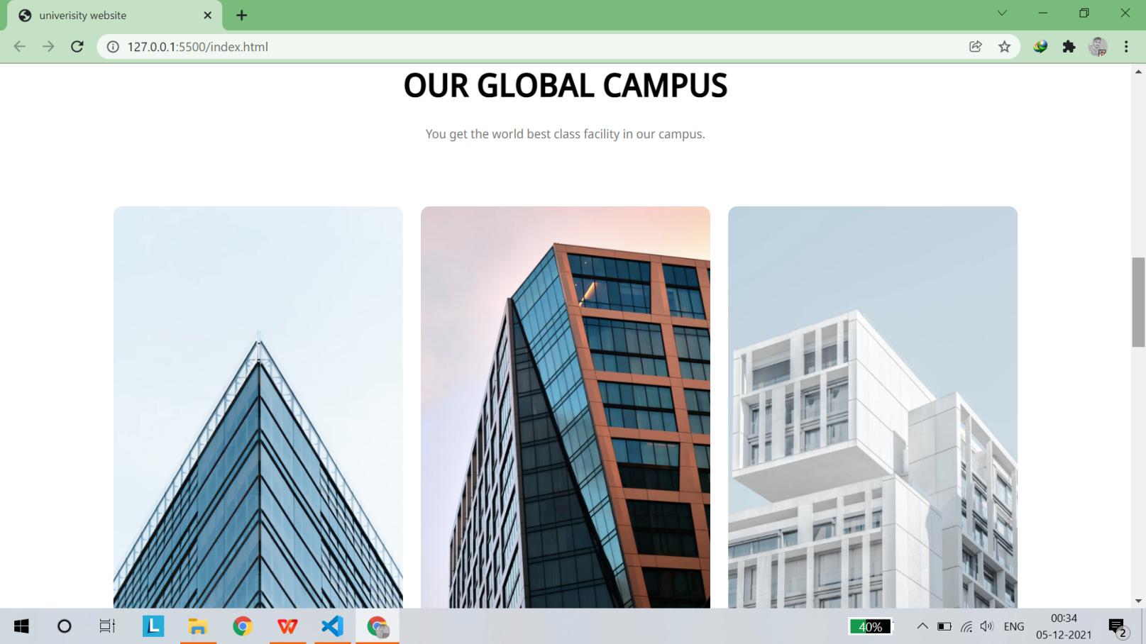

*Fig 2 HOME PAGE-2 CAMPUS VIEW*

*(6)*

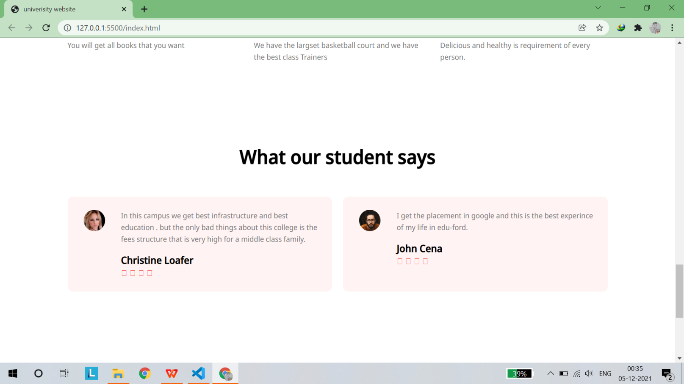

*Fig 3 STUDENTS REVIEWS*

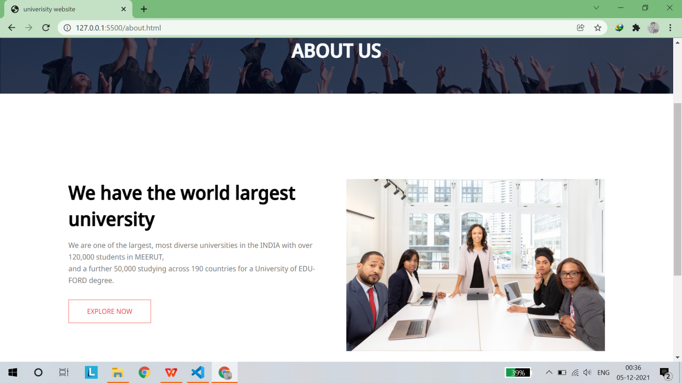

*Fig 4 ABOUT US*

(7)

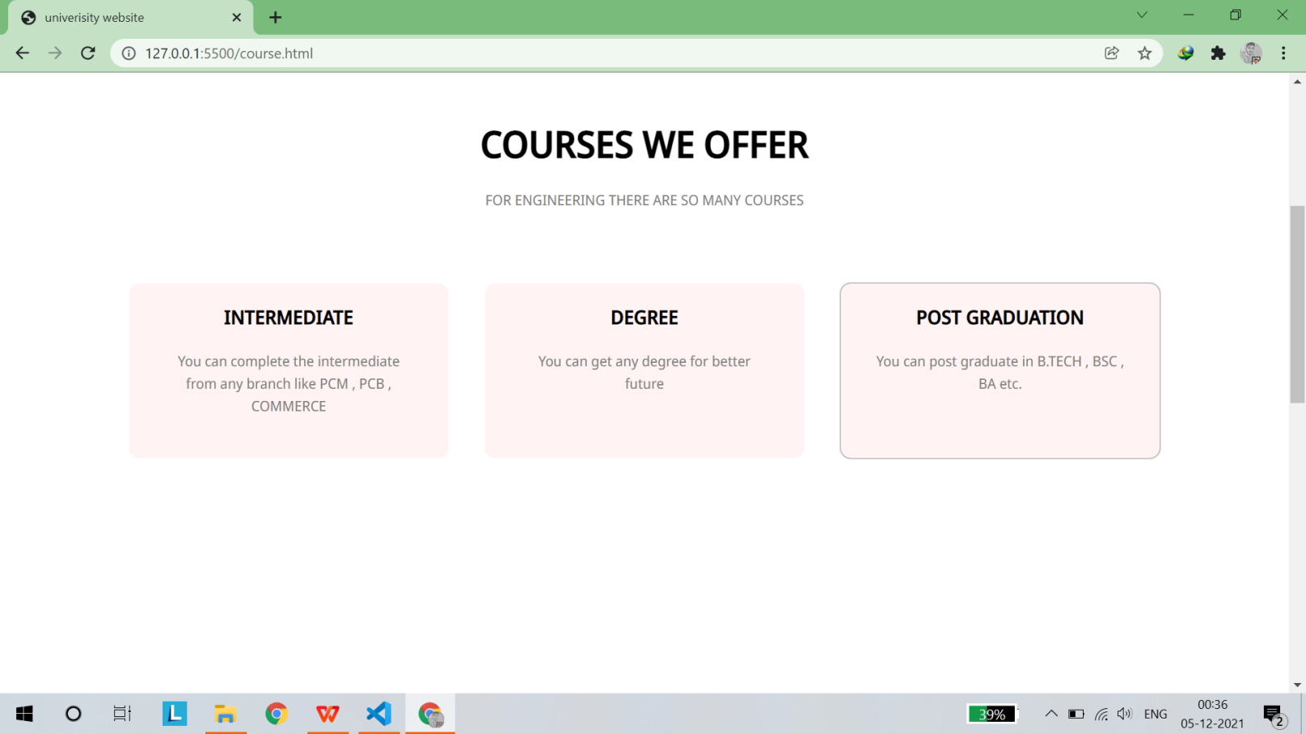

*Fig 5 COURSES WE OFFER*

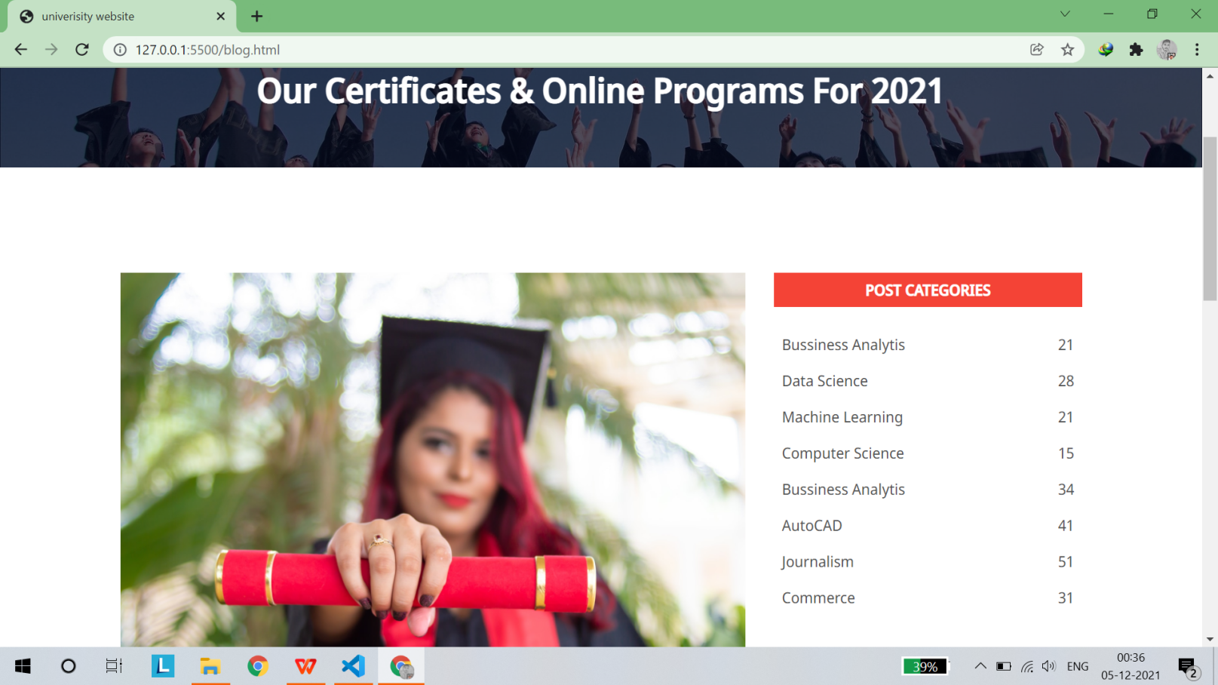

*Fig 6 OUR CERTIFICATES (a)*

(8)

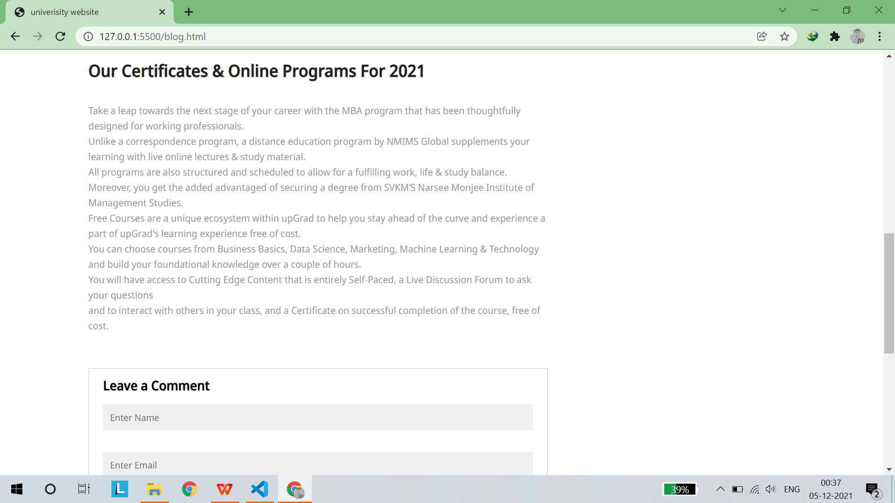

*Fig 7 OUR CERTIFICATES (b)*

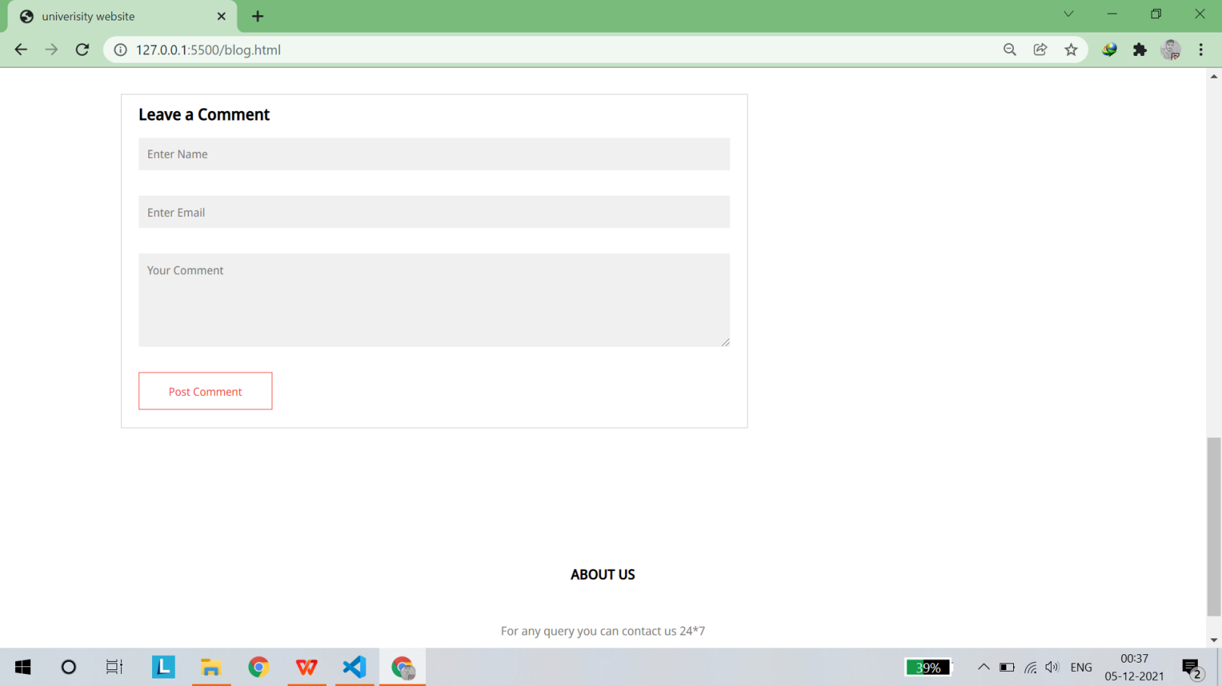

*Fig 8 COMMENT SECTION*

(9)

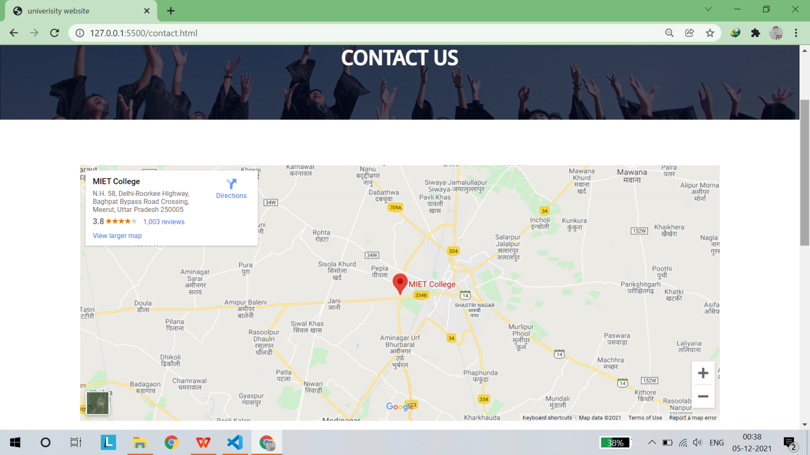

*Fig 9 CONTACT US(a)*

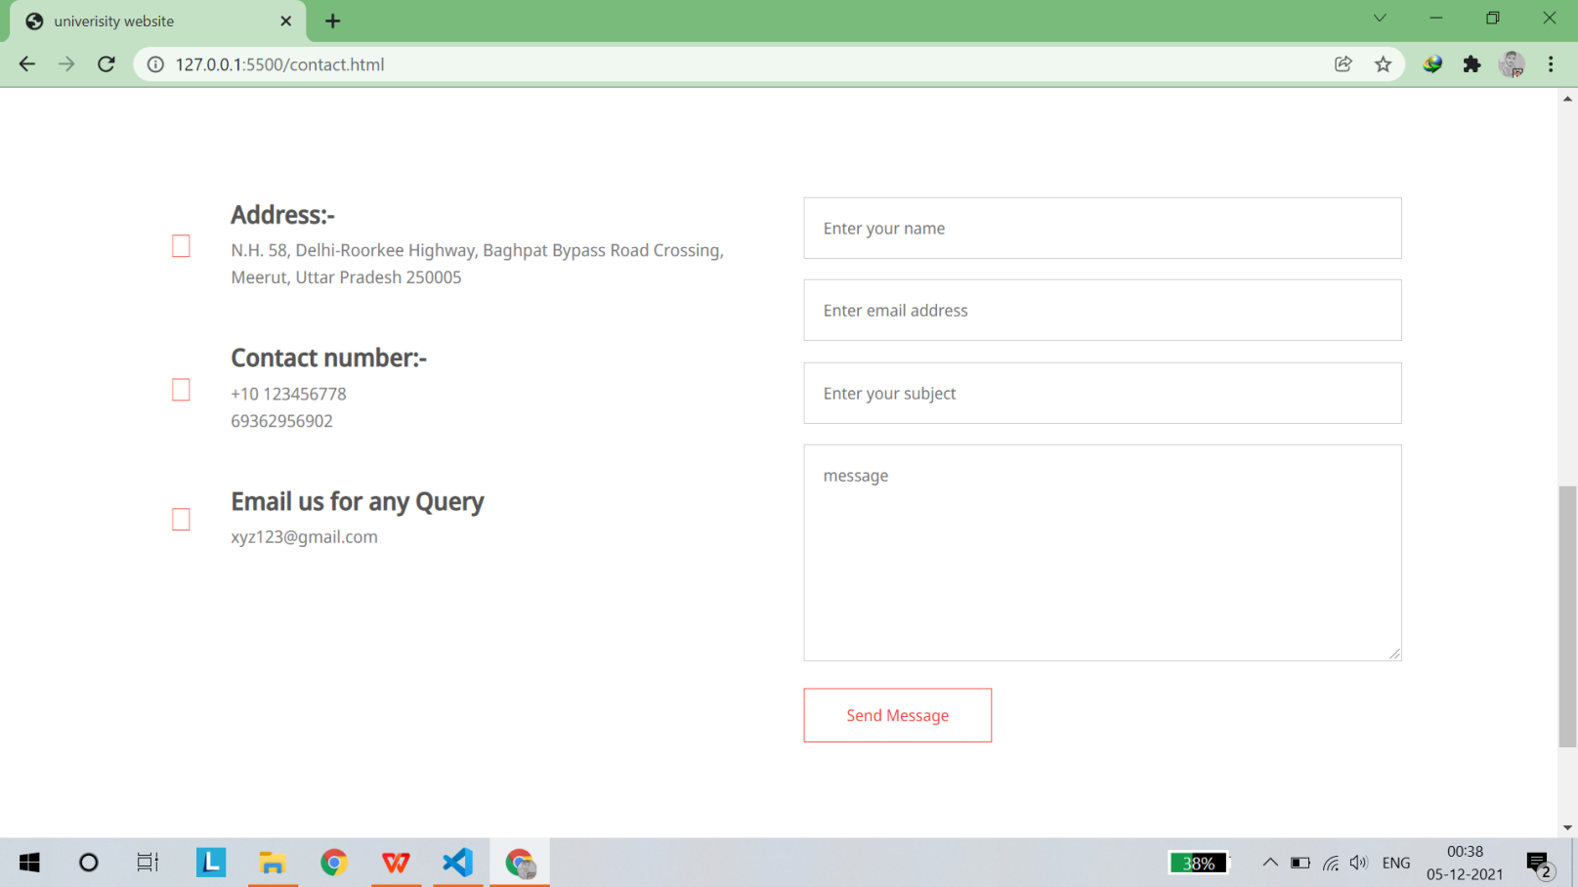

*Fig 10 CONTACT US(b)*

(10)

**APPENDICES IMPLEMENTATION OF CODE**

**HOME PAGE’S HTML AND CSS CODE**

<!DOCTYPE html>

<html lang="en">

<head>

<meta name="viewport" content="width=device-width, intial-scale=1.0">

<title>univerisity website</title>

<link rel="stylesheet" href="style.css">

<link rel="preconnect" href="https://fonts.googleapis.com">

<link rel="preconnect" href="https://fonts.gstatic.com" crossorigin>

<link href="https://fonts.googleapis.com/css2?family=Noto+Sans+Display:wght@200;300;400;500&display=swap" rel="stylesheet">

<link rel="stylesheet" href="https://cdn.jsdelivr.net/npm/@fortawesome/fontawesome-free@5.15.4/css/fontawesome.min.css">

<link rel="stylesheet" href="https://cdn.jsdelivr.net/npm/@fortawesome/fontawesome-free@5.15.4/css/fontawesome.min.css" integrity="sha384-jLKHWM3JRmfMU0A5x5AkjWkw/EYfGUAGagvnfryNV3F9VqM98XiIH7VBGVoxVSc7" crossorigin="anonymous">

</head>

<body>

<section class="header">

<nav>

<a href="index.html">

<img src="images/logo.png">

</a>

<div class="nav-links">

<ul>

<li><a href="index.html">HOME</a></li>

<li><a href="about.html">ABOUT</a></li>

<li><a href="course.html">COURSE</a></li>

<li><a href="blog.html">ADMISSION</a></li>

<li><a href="contact.html">CONTACT US</a></li>

</ul>

</div>

</nav>

<div class="text-box">

<h1>INDIA LARGEST ENGINEERING COLLEGE</h1>

<p>

Our college provide the world best quality education ,

<br> come and grab the opportunities as soon as possible

</p>

<a href="" class="hero-btn">visit to us for know (11)

more</a>

</div>

</section>

<!---course---->

<section class="course">

<h1>

COURSES WE OFFER

</h1>

<P>

FOR ENGINEERING THERE ARE SO MANY COURSES

</P>

<div class="row">

<div class="course-col">

<h3>

INTERMEDIATE

</h3>

<P>

You can complete the intermediate from any branch like PCM , PCB , COMMERCE

</P>

</div>

<div class="course-col">

<h3>

DEGREE

</h3>

<P>

You can get any degree for better future

</P>

</div>

<div class="course-col">

<h3>

POST GRADUATION

</H3>

<P>

You can post graduate in B.TECH , BSC , BA etc.

</P>

</div>

</div>

</section> (12)

<!---CAMPUS-->

<section class="campus">

<h1>

OUR GLOBAL CAMPUS

</h1>

<p>

You get the world best class facility in our campus.

</p>

<div class="row">

<div class="campus-col">

<img src="images/london.png">

<div class="layer">

<h3>MUMBAI</h3>

</div>

</div>

<div class="campus-col">

<img src="images/newyork.png">

<div class="layer">

<h3>NEW DELHI</h3>

</div>

</div>

<div class="campus-col">

<img src="images/washington.png">

<div class="layer">

<h3>PATNA</h3>

</div>

</div>

</div>

</section>

<!----facilities-->

<section class="facilities">

<h1> OUR FACILITIES</h1>

<p>

In our campus you will get all type of facilities like sports grounds , library , wifi ,<br>

vehicles parking , large grounds , swimming polls , canteens and other facilities.

</p>

<div class="row">

<div class="facilities-col"> (13)

<img src="images/library.png" >

<h3>

World class library

</h3>

<p>

You will get all books that you want

</p>

</div>

<div class="facilities-col">

<img src="images/basketball.png" >

<h3>

Largest Basketball court

</h3>

<p>

We have the largset basketball court and we have the best class Trainers

</p>

</div>

<div class="facilities-col">

<img src="images/cafeteria.png" >

<h3>

Tasty and Healthy Food

</h3>

<p>

Delicious and healthy is requirement of every person.

</p>

</div>

</div>

</section>

<!---testimonials--->

<section class="testimonials">

<h1>

What our student says

</h1>

<div class="row">

<div class="testimonials-col">

<img src="images/user1.jpg" >

<div>

<p> In this campus we get best infrastructure and best education .

but the only bad things about this college is the fees structure that

is very high for a middle class family.

</p>

<h3>

Christine Loafer (14)

</h3>

<i class="fa fa-star" ></i>

<i class="fa fa-star" ></i>

<i class="fa fa-star" ></i>

<i class="fa fa-star" ></i>

<i class="fa fa-star-o" ></i>

</div>

</div>

<div class="testimonials-col">

<img src="images/user2.jpg" >

<div>

<p>

I get the placement in google and this is the best experince of my life in edu-ford.

</p>

<h3>

John Cena

</h3>

<i class="fa fa-star" ></i>

<i class="fa fa-star" ></i>

<i class="fa fa-star" ></i>

<i class="fa fa-star" ></i>

<i class="fa fa-star-half-o" ></i>

</div>

</div>

</div>

</section>

<section class="cta">

<h1>

Enroll for our variable online courses <br>

from anywhere of the world

</h1>

<a href="" class="hero-btn">CONTACT US</a>

</section>

<!---footer-->

<section class="footer">

<h4>

ABOUT US

</h4>

<P>For any query you can contact us 24*7 </P>

<div class="icons">

<i class="fa fa-facebook"></i>

<i class="fa fa-twitter"></i>

<i class="fa fa-instagram"></i> (15)

<i class="fa fa-linkedin"></i>

</div>

</section>

</body>

</html>

*{

padding: 0%;

margin: 0%;

font-family: 'Noto Sans Display', sans-serif;

}

.header{

min-height: 100vh;

width: 100%;

background-image: linear-gradient(rgba(4,9,30,0.7),rgba(4,9,30,0.7)),url(images/banner.png);

background-position: center;

background-size: cover;

position: relative;

}

nav{

display: flex;

padding: 2% 6%;

justify-content: space-between;

align-items: center;

}

nav img{

width: 150px;

}

.nav-links{

flex: 1;

text-align: right;

}

.nav-links ul li{

list-style: none;

display: inline-block;

padding: 8px 12px;

position: relative;

}

.nav-links ul li a{

color: #fff;

text-decoration: none;

font-size: 13px;

} (16)

.nav-links ul li::after{

content: '';

width: 0%;

height: 2px;

background: #f44336;

display:block;

margin: auto;

transition: 0.5s ;

}

.nav-links ul li:hover::after{

width: 100%;

}

.text-box{

width: 90%;

color: #fff;

position: absolute;

top: 50%;

left: 50%;

transform: translate(-50%,-50%);

text-align:center;

}

.text-box h1{

font-size: 62px;

}

.text-box p{

margin:10px 0px 40px;

font-size: 24px;

}

.hero-btn{

display: inline-block;

text-decoration: none;

color: white;

border: 1px solid white;

padding: 12px 34px ;

font-size: 13px;

background: transparent;

position: relative;

cursor: pointer;

}

.hero-btn:hover{

border: 1px solid #f44336;

background: #f44336;

transition: 1s;

} (17)

@media(max-width:700px){

.text-box h1{

font-size: 20px;

}

.nav-links ul li{

display:block;

}

.nav-links{

position: absolute;

background: #f44336;

height:100px;

width:200px;

top: 0;

right: 0;

text-align: left;

z-index: 2;

}

}

.course{

width: 80%;

margin: auto;

text-align: center;

padding: 100px;

}

h1{

font-size: 36px;

font-weight: 600;

}

p{

font-size: 14px;

color:gray;

font-weight: 300px;

line-height: 22px;

padding: 20px;

}

.row{

margin-top: 5%;

display: FLEX;

justify-content: space-between;

} (18)

.course-col{

flex-basis: 31%;

background: #fff3f3;

border-radius: 10px;

margin-bottom: 5%;

padding:20px 12px;

box-sizing:border-box ;

transition: 0.5s;

}

.h3{

text-align:center;

font-weight: 600;

margin: 10px 0;

}

.course-col:hover{

box-shadow: 0 0 2px 0px ;

}

/*--campus---*/

.campus{

width: 80%;

margin:auto;

text-align: center;

padding-top: 20px;

}

.campus-col{

flex-basis: 32%;

border-radius: 10px;

margin-bottom: 30px;

position: relative;

overflow: hidden;

}

.campus-col img{

width: 100%;

display: block;

}

.layer{

height: 100%;

width: 100%;

position: absolute;

top: 0;

left: 0;

background: transparent;

transition: 0.5s; (19)

}

.layer:hover{

background: rgba(226,0,0,0.7);

}

.layer h3{

width: 100%;

font-weight: 500;

color: #fff;

font-size: 26px;

bottom: 0;

left: 50%;

transform: translateX(-50%);

position: absolute;

opacity:0;

transition: 0.5s;

}

.layer:hover h3{

bottom:45%;

opacity:1;

}

/*---- faciclities---*/

.facilities{

width: 80%;

margin: auto;

text-align: center;

padding: top;

margin-top: 100px;

}

.facilities-col{

flex-basis: 31%;

border-radius: 10%;

margin-bottom: 5%;

text-align: left;

}

.facilities-col img{

width: 100%;

border-radius: 10px;

}

.facilities-col p{

padding: 0;

}

.facilities-col h3{

margin-top: 16px; (20)

margin-bottom: 15px;

text-align: left;

}

.testimonials{

width: 80%;

margin: auto;

padding-top: 100px;

text-align: center;

}

.testimonials-col{

flex-basis: 44%;

border-radius:10px;

margin-bottom: 5%;

text-align: left;

background: #fff3f3;

padding: 25px;

cursor: pointer;

display: flex ;

}

.testimonials-col img{

height:40px;

margin-left: 5px;

margin-right:30px;

border-radius: 50px;

}

.testimonials-col p{

padding: 0;

}

.testimonials-col h3{

margin-top: 15px;

text-align: left ;

}

.testimonials-col .fa{

color: #f44336;

}

/*-----call to action---*/

.cta{

margin: 100px auto;

width: 80%;

background-image: linear-gradient(rgba(0,0,0,0.7),rgba(0,0,0,0.7) ),url(images/banner2.jpg);

background-position: cover ;

border-radius: 10px;

text-align: center;

padding: 100px 0;

} (21)

.cta{

color: #fff;

margin-bottom: 40px;

padding: 0;

}

.footer{

width: 100%;

text-align: center;

padding: 30px 0;

}

.footer h4{

margin-bottom: 25px;

margin-top: 20px;

font-weight: 600;

}

(22)

# ABOUT US HTML AND CSS CODE

<!DOCTYPE html>

<html lang="en">

<head>

<meta name="viewport" content="width=device-width, intial-scale=1.0">

<title>univerisity website</title>

<link rel="stylesheet" href="style.css">

<link rel="preconnect" href="https://fonts.googleapis.com">

<link rel="preconnect" href="https://fonts.gstatic.com" crossorigin>

<link href="https://fonts.googleapis.com/css2?family=Noto+Sans+Display:wght@200;300;400;500&display=swap" rel="stylesheet">

<link rel="stylesheet" href="https://cdn.jsdelivr.net/npm/@fortawesome/fontawesome-free@5.15.4/css/fontawesome.min.css">

<link rel="stylesheet" href="https://cdn.jsdelivr.net/npm/@fortawesome/fontawesome-free@5.15.4/css/fontawesome.min.css" integrity="sha384-jLKHWM3JRmfMU0A5x5AkjWkw/EYfGUAGagvnfryNV3F9VqM98XiIH7VBGVoxVSc7" crossorigin="anonymous">

</head>

<body>

<section class="sub-header">

<nav>

<a href="index.html">

<img src="images/logo.png">

</a>

<div class="nav-links">

<ul>

<li><a href="index.html">HOME</a></li>

<li><a href="about.html">ABOUT</a></li>

<li><a href="course.html">COURSE</a></li>

<li><a href="blog.html">ADMISSION</a></li>

<li><a href="contact.html">CONTACT US</a></li>

</ul>

</div>

</nav>

<h1>

ABOUT US

</h1>

</section>

<!-----about us----->

<section class="about-us">

<div class="row">

<div class="about-col">

<h1>

We have the world largest university

</h1>

<p>

We are one of the largest, most diverse universities in the INDIA with over 120,000 students in MEERUT,<br>

and a further 50,000 studying across 190 countries for a University of EDU-FORD degree.

</p>

<a href="" class="hero-btn red-btn">EXPLORE NOW</a>

</div>

<div class="about-col">

<img src="images/about.jpg" > (23)

</div>

</div>

</section>

<!---footer-->

<section class="footer">

<h4>

ABOUT US

</h4>

<P>For any query you can contact us 24*7 </P>

<div class="icons">

<i class="fa fa-facebook"></i>

<i class="fa fa-twitter"></i>

<i class="fa fa-instagram"></i>

<i class="fa fa-linkedin"></i>

</div>

</section>

</body>

</html>

/*-----about us----*/

.sub-header{

height: 50vh;

width: 100%;

background-image: linear-gradient(rgba(4,9,30,0.7),rgba(4,9,30,0.7)),url(images/background.jpg);

background-position: center;

background-size: cover;

text-align: center;

color: #fff;

}

.sub-header h1{

margin-top: 100px;

}

.about-us{

width: 80%;

margin: auto;

padding-top: 80px;

padding-bottom: 50px;

}

.about-col{

flex-basis: 48%;

padding: 30px 2px;

}

.about-col img{

width: 100%;

}

.about-col h1{

padding-top: 0;

}

.about-col p{

padding: 15px 0 25px;

}

.red-btn{

border: 1px solid #f44336;

background: transparent;

color: #f44336; (24)

}

.red-btn:hover{

color: #fff;

}

.blog-content{

width: 80%;

margin: auto;

padding: 60px 0;

}

.blog-left{

flex-basis: 65%;

}

.blog-left img{

width: 100%;

}

.blog-left h2{

color: #222;

font-weight: 600;

margin: 30px 0;

}

.blog-left p{

color: #999;

padding: 0;

}

.blog-right{

flex-basis: 32%;

}

.blog-right h3{

background: #f44336;

color: #fff;

padding: 7px 0;

font-size: 16px;

margin-bottom: 20px;

text-align: center;

}

.blog-right div{

display: flex;

align-items: center;

justify-content: space-between;

color: #555;

padding: 8px;

box-sizing: border-box;

}

.comment-box{

border: 1px solid #ccc;

margin: 50px 0;

padding: 10px 20px;

}

.comment-box h3{

text-align: left;

}

.comment-form input, .comment-form textarea{ (25)

width: 100%;

padding: 10px;

margin: 15px 0;

box-sizing: border-box;

border: none;

outline: none;

background: #f0f0f0;

}

.comment-form button{

margin: 10px 0;

}

(26)

**COURSE HTML AND CSS CODE**

<!DOCTYPE html>

<html lang="en">

<head>

<meta name="viewport" content="width=device-width, intial-scale=1.0">

<title>univerisity website</title>

<link rel="stylesheet" href="style.css">

<link rel="preconnect" href="https://fonts.googleapis.com">

<link rel="preconnect" href="https://fonts.gstatic.com" crossorigin>

<link href="https://fonts.googleapis.com/css2?family=Noto+Sans+Display:wght@200;300;400;500&display=swap" rel="stylesheet">

<link rel="stylesheet" href="https://cdn.jsdelivr.net/npm/@fortawesome/fontawesome-free@5.15.4/css/fontawesome.min.css">

<link rel="stylesheet" href="https://cdn.jsdelivr.net/npm/@fortawesome/fontawesome-free@5.15.4/css/fontawesome.min.css" integrity="sha384-jLKHWM3JRmfMU0A5x5AkjWkw/EYfGUAGagvnfryNV3F9VqM98XiIH7VBGVoxVSc7" crossorigin="anonymous">

</head>

<body>

<section class="sub-header">

<nav>

<a href="index.html">

<img src="images/logo.png">

</a>

<div class="nav-links">

<ul>

<li><a href="index.html">HOME</a></li>

<li><a href="about.html">ABOUT</a></li>

<li><a href="course.html">COURSE</a></li>

<li><a href="blog.html">ADMISSION</a></li>

<li><a href="contact.html">CONTACT US</a></li>

</ul>

</div>

</nav>

<h1>

OUR COURSES

</h1>

</section>

<!-----course----->

<section class="course">

<h1>

COURSES WE OFFER

</h1>

<P>

FOR ENGINEERING THERE ARE SO MANY COURSES

</P>

<div class="row">

<div class="course-col">

<h3>

INTERMEDIATE

</h3>

<P>

You can complete the intermediate from any branch like PCM , PCB , COMMERCE (27)

</P>

</div>

<div class="course-col">

<h3>

DEGREE

</h3>

<P>

You can get any degree for better future

</P>

</div>

<div class="course-col">

<h3>

POST GRADUATION

</H3>

<P>

You can post graduate in B.TECH , BSC , BA etc.

</P>

</div>

</div>

</section>

<!----facilities-->

<section class="facilities">

<h1> OUR FACILITIES</h1>

<p>

In our campus you will get all type of facilities like sports grounds , library , wifi ,<br>

vehicles parking , large grounds , swimming polls , canteens and other facilities.

</p>

<div class="row">

<div class="facilities-col">

<img src="images/library.png" >

<h3>

World class library

</h3>

<p>

You will get all books that you want

</p>

</div>

<div class="facilities-col">

<img src="images/basketball.png" >

<h3>

Largest Basketball court

</h3>

<p>

We have the largset basketball court and we have the best class Trainers

</p>

</div>

<div class="facilities-col"> (28)

<img src="images/cafeteria.png" >

<h3>

Tasty and Healthy Food

</h3>

<p>

Delicious and healthy is requirement of every person.

</p>

</div>

</div>

</section>

<!---footer-->

<section class="footer">

<h4>

ABOUT US

</h4>

<P>For any query you can contact us 24*7 </P>

<div class="icons">

<i class="fa fa-facebook"></i>

<i class="fa fa-twitter"></i>

<i class="fa fa-instagram"></i>

<i class="fa fa-linkedin"></i>

</div>

</section>

</body>

</html>

(29)

# ADMISSION HTML AND CSS CODE

<!DOCTYPE html>

<html lang="en">

<head>

<meta name="viewport" content="width=device-width, intial-scale=1.0">

<title>univerisity website</title>

<link rel="stylesheet" href="style.css">

<link rel="preconnect" href="https://fonts.googleapis.com">

<link rel="preconnect" href="https://fonts.gstatic.com" crossorigin>

<link href="https://fonts.googleapis.com/css2?family=Noto+Sans+Display:wght@200;300;400;500&display=swap" rel="stylesheet">

<link rel="stylesheet" href="https://cdn.jsdelivr.net/npm/@fortawesome/fontawesome-free@5.15.4/css/fontawesome.min.css">

<link rel="stylesheet" href="https://cdn.jsdelivr.net/npm/@fortawesome/fontawesome-free@5.15.4/css/fontawesome.min.css" integrity="sha384-jLKHWM3JRmfMU0A5x5AkjWkw/EYfGUAGagvnfryNV3F9VqM98XiIH7VBGVoxVSc7" crossorigin="anonymous">

</head>

<body>

<section class="sub-header">

<nav>

<a href="index.html">

<img src="images/logo.png">

</a>

<div class="nav-links">

<ul>

<li><a href="index.html">HOME</a></li>

<li><a href="about.html">ABOUT</a></li>

<li><a href="course.html">COURSE</a></li>

<li><a href="blog.html">ADMISSION</a></li>

<li><a href="contact.html">CONTACT US</a></li>

</ul>

</div>

</nav>

<h1>

Our Certificates & Online Programs For 2021

</h1>

</section>

<!--blog page content-->

<section class="blog-content">

<div class="row">

<div class="blog-left">

<img src="images/certificate.jpg" >

<h2>Our Certificates & Online Programs For 2021</h2>

<p>

Take a leap towards the next stage of your career with the MBA program that has been thoughtfully designed for working professionals.<br>

Unlike a correspondence program, a distance education program by NMIMS Global supplements your learning with live online lectures & study material.

<br> All programs are also structured and scheduled to allow for a fulfilling work, life & study balance.<br>

Moreover, you get the added advantaged of securing a degree from SVKM’S Narsee Monjee Institute of Management Studies.<br>

Free Courses are a unique ecosystem within upGrad to help you stay ahead of the curve and experience a part of upGrad's learning experience free of cost.<br> (30)

You can choose courses from Business Basics, Data Science, Marketing, Machine Learning & Technology and build your foundational knowledge over a couple of hours.<br>

You will have access to Cutting Edge Content that is entirely Self-Paced, a Live Discussion Forum to ask your questions <br>

and to interact with others in your class, and a Certificate on successful completion of the course, free of cost.

</p>

<div class="comment-box">

<h3>Leave a Comment</h3>

<form class="comment-form">

<input type="text" placeholder="Enter Name">

<input type="text" placeholder="Enter Email">

<textarea rows="5" placeholder="Your Comment"></textarea>

<button type="submit" class="hero-btn red-btn">Post Comment</button>

</form>

</div>

</div>

<div class="blog-right">

<h3>

POST CATEGORIES

</h3>

<div>

<span>Bussiness Analytis</span>

<span>21</span>

</div>

<div>

<span>Data Science</span>

<span>28</span>

</div>

<div>

<span>Machine Learning</span>

<span>21</span>

</div>

<div>

<span>Computer Science</span>

<span>15</span>

</div>

<div>

<span>Bussiness Analytis</span>

<span>34</span>

</div>

<div>

<span>AutoCAD</span>

<span>41</span>

</div>

<div>

<span>Journalism</span>

<span>51</span>

</div>

<div>

<span>Commerce</span>

<span>31</span>

</div>

</div>

</div>

</section> (31)

<!---footer-->

<section class="footer">

<h4>

ABOUT US

</h4>

<P>For any query you can contact us 24*7 </P>

<div class="icons">

<i class="fa fa-facebook"></i>

<i class="fa fa-twitter"></i>

<i class="fa fa-instagram"></i>

<i class="fa fa-linkedin"></i>

</div>

</section>

</body>

</html>

.blog-content{

width: 80%;

margin: auto;

padding: 60px 0;

}

.blog-left{

flex-basis: 65%;

}

.blog-left img{

width: 100%;

}

.blog-left h2{

color: #222;

font-weight: 600;

margin: 30px 0;

}

.blog-left p{

color: #999;

padding: 0;

}

.blog-right{

flex-basis: 32%;

}

.blog-right h3{

background: #f44336;

color: #fff;

padding: 7px 0;

font-size: 16px;

margin-bottom: 20px;

text-align: center;

}

.blog-right div{

display: flex;

align-items: center; (32)

justify-content: space-between;

color: #555;

padding: 8px;

box-sizing: border-box;

}

.comment-box{

border: 1px solid #ccc;

margin: 50px 0;

padding: 10px 20px;

}

.comment-box h3{

text-align: left;

}

.comment-form input, .comment-form textarea{

width: 100%;

padding: 10px;

margin: 15px 0;

box-sizing: border-box;

border: none;

outline: none;

background: #f0f0f0;

}

.comment-form button{

margin: 10px 0;

}

# (33)

# CONTACT US HTML AND CSS CODE

<!DOCTYPE html>

<html lang="en">

<head>

<meta name="viewport" content="width=device-width, intial-scale=1.0">

<title>univerisity website</title>

<link rel="stylesheet" href="style.css">

<link rel="preconnect" href="https://fonts.googleapis.com">

<link rel="preconnect" href="https://fonts.gstatic.com" crossorigin>

<link href="https://fonts.googleapis.com/css2?family=Noto+Sans+Display:wght@200;300;400;500&display=swap" rel="stylesheet">

<link rel="stylesheet" href="https://cdn.jsdelivr.net/npm/@fortawesome/fontawesome-free@5.15.4/css/fontawesome.min.css">

<link rel="stylesheet" href="https://cdn.jsdelivr.net/npm/@fortawesome/fontawesome-free@5.15.4/css/fontawesome.min.css" integrity="sha384-jLKHWM3JRmfMU0A5x5AkjWkw/EYfGUAGagvnfryNV3F9VqM98XiIH7VBGVoxVSc7" crossorigin="anonymous">

</head>

<body>

<section class="sub-header">

<nav>

<a href="index.html">

<img src="images/logo.png">

</a>

<div class="nav-links">

<ul>

<li><a href="index.html">HOME</a></li>

<li><a href="about.html">ABOUT</a></li>

<li><a href="course.html">COURSE</a></li>

<li><a href="blog.html">ADMISSION</a></li>

<li><a href="contact.html">CONTACT US</a></li>

</ul>

</div>

</nav>

<h1>

CONTACT US

</h1>

</section>

<!----ccntact us----->

<section class="location">

<iframe src="https://www.google.com/maps/embed?pb=!1m18!1m12!1m3!1d111708.82651583946!2d77.69499701329919!3d28.96066580672336!2m3!1f0!2f0!3f0!3m2!1i1024!2i768!4f13.1!3m3!1m2!1s0x390c668fdea4d87f%3A0x8795def814a486e7!2sMIET%20College!5e0!3m2!1sen!2sin!4v1638129076098!5m2!1sen!2sin" width="600" height="450" style="border:0;" allowfullscreen="" loading="lazy"></iframe>

</section>

<section class="contact-us">

<div class="row">

<div class="contact-col">

<div>

<i class="fa fa-home"></i>

<span>

<h5> (34)

Address:-

</h5>

<p> N.H. 58, Delhi-Roorkee Highway, Baghpat Bypass Road Crossing, Meerut, Uttar Pradesh 250005</p>

</span>

</div>

<div>

<i class="fa fa-phone"></i>

<span>

<h5>

Contact number:-

</h5>

<p> +10 123456778 <br> 69362956902</p>

</span>

</div>

<div>

<i class="fa fa-envelope"></i>

<span>

<h5>

Email us for any Query

</h5>

<p> xyz123@gmail.com</p>

</span>

</div>

</div>

<div class="contact-col">

<input type="text" placeholder="Enter your name " required>

<input type="text" placeholder="Enter email address " required>

<input type="text" placeholder="Enter your subject " required>

<textarea rows="8" placeholder="message" required></textarea>

<button type="submit" class="hero-btn red-btn">Send Message</button>

</div>

</div>

</section>

<!---footer-->

<section class="footer">

<h4>

ABOUT US

</h4>

<P>For any query you can contact us 24*7 </P>

<div class="icons">

<i class="fa fa-facebook"></i>

<i class="fa fa-twitter"></i>

<i class="fa fa-instagram"></i>

<i class="fa fa-linkedin"></i>

</div>

</section>

</body>

</html>

/*----contact us-----*/

.location{

width: 80%; (35)

margin: auto;

padding: 80px 0;

}

.location iframe{

width: 100%;

}

.contact-us{

width: 80%;

margin: auto;

}

.contact-col{

flex-basis: 48%;

margin-bottom: 30px;

}

.contact-col div{

display: flex;

align-items: center;

margin-bottom: 40px;

}

.contact-col div .fa{

font-size: 28px;

color: #f44336;

margin: 10px;

margin-right: 30px;

}

.contact-col div p{

padding: 0;

}

.contact-col div h5{

font-size: 20px;

margin-bottom: 5px;

color: #555;

font-weight: 400px;

}

.contact-col input,.contact-col textarea{

width: 100%;

padding: 15px;

margin-bottom: 17px;

outline: none;

border: 1px solid #ccc;

box-sizing: border-box;

}

(36)

# REFERENCES

1. **https://[www.w3schools.com/](http://www.w3schools.com/)**
2. **https://www%2Cstackoverflow.com/**
3. **https://[www.cssbasics.com/](http://www.cssbasics.com/)**

(38)